Milestone 1: Foundation & Data Architecture Documentation

Project Structure Overview
Below is the initialized directory structure for our local engineering environment, highlighting where the completed Milestone 1 artifacts are stored.
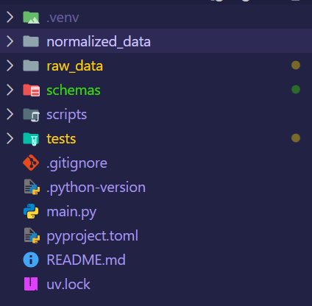
10.1 Data Review and Normalization
- Review all provided JSON samples, attached assets, descriptive notes, and special case prompts.
  - Status: Completed.
  - Implementation: We fully analyzed the raw files (LAS 4_V8_links_data with Descriptions.txt and Feb_10_project_data.txt) inside the /raw_data folder. We reviewed all multi-asset page definitions, conversational descriptions, and varying layout densities (from single-image full-page ads to complex multi-column editorial pages).
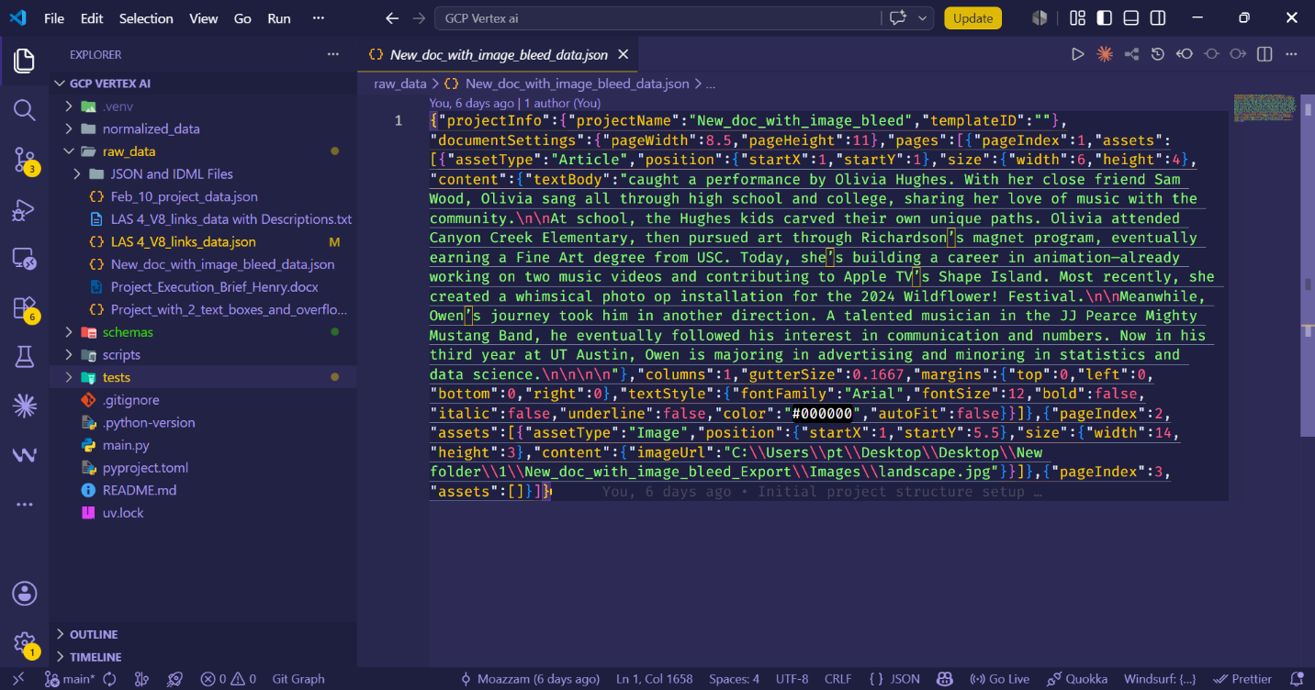
- Identify inconsistent formatting, duplicate keys, malformed values, or export artifacts.
  - Status: Completed.
  - Implementation: We developed a robust Python extraction script (scripts/build_context_pairs.py) that successfully identified and stripped out parsing bugs. We caught and fixed JSON control character issues and corrected structural shifts where page descriptions were bleeding across adjacent records.
- Map raw paths, asset references, and page structures into a clean, reusable structure.
  - Status: Completed.
  - Implementation: The extraction script paired the raw conversational text (the natural language intent) directly with its validated target layout JSON. This compiled flawless learning pairs into a clean array, securely saved as normalized_data/layout_prompt_library.json. This completely offline file now acts as our production-ready Few-Shot Prompt Library.
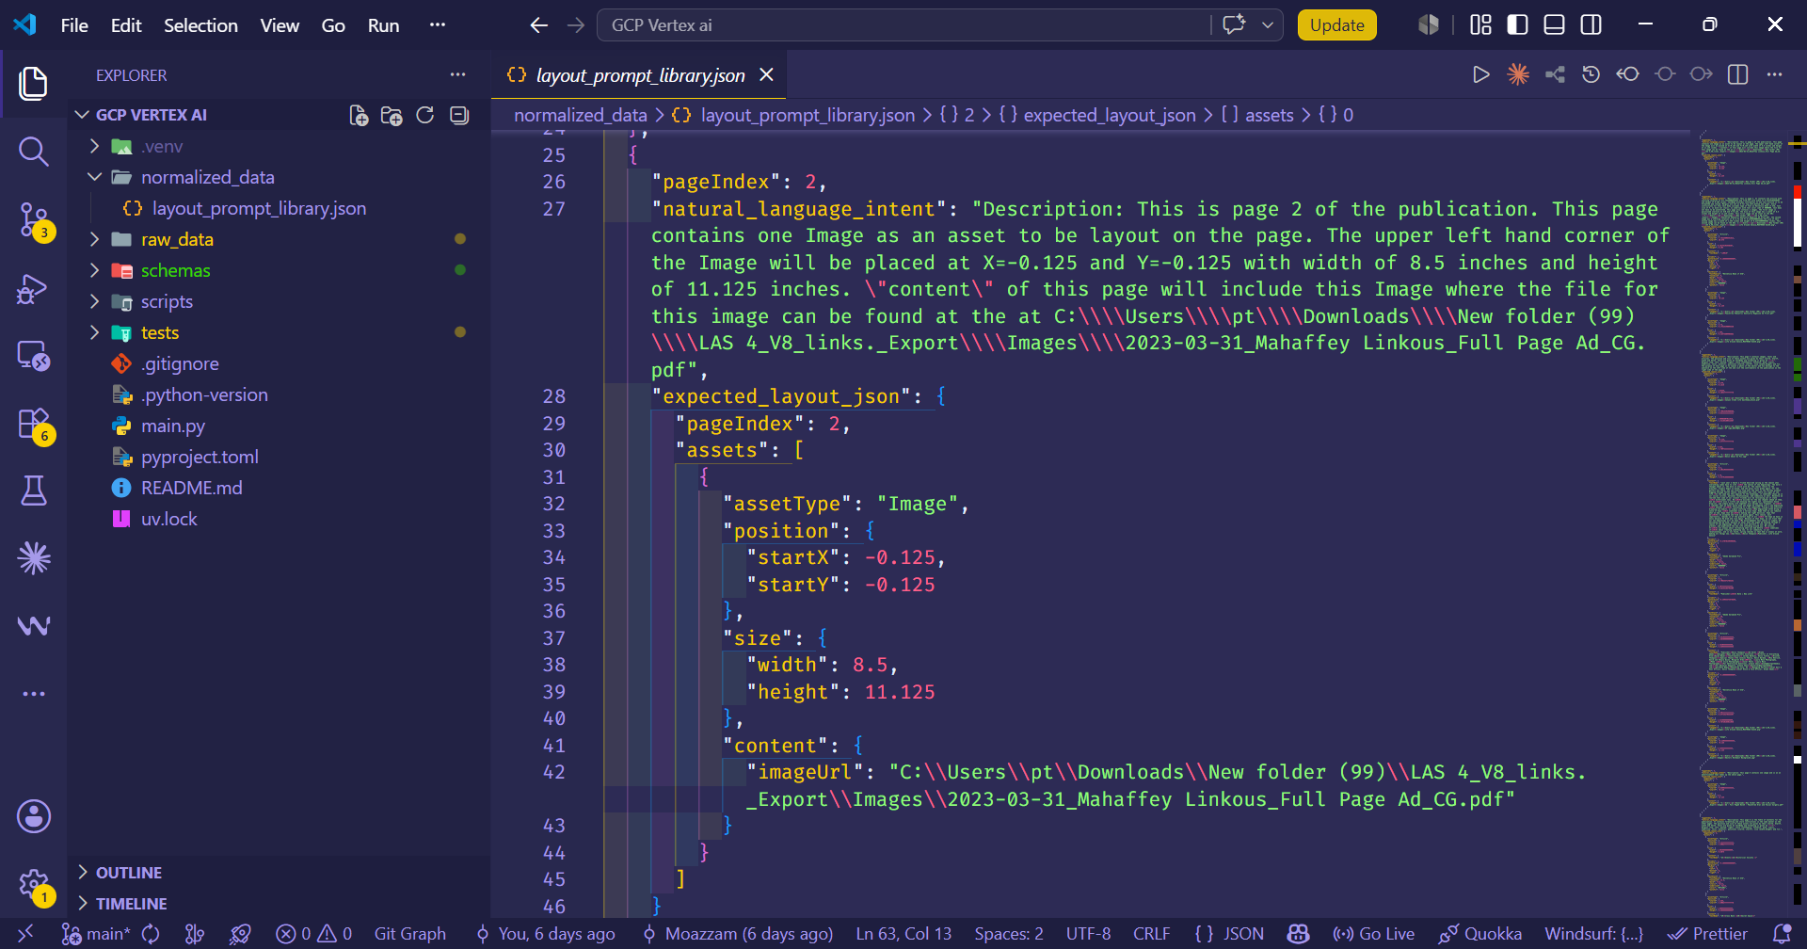
- Create internal reference notes for page roles and layout patterns.
  - Status: Completed.
  - Implementation: Structural behaviors and contextual edge cases (e.g., handling negative coordinates for image bleeds, and standardizing multi-column gutters) were isolated. We logged these patterns into the /docs workspace path to serve as a strict reference for downstream system alignment.
10.2 Schema Mapping
- Document top-level schema blocks such as project info, document settings, pages, assetsText, assetsImage, assetsAd, styles, positions, and sizes.
  - Status: Completed.
  - Implementation: We mapped the raw Adobe concepts into strict, object-oriented data schemas natively in Python. Inside schemas/layout_schema.py, we created dedicated Pydantic models for ProjectInfo, DocumentSettings, Page, Asset, TextStyle, Position, and Size. We specifically expanded the assetType parameter to natively support Literal["Article", "Image", "Ad"] to accommodate advertisement configurations.
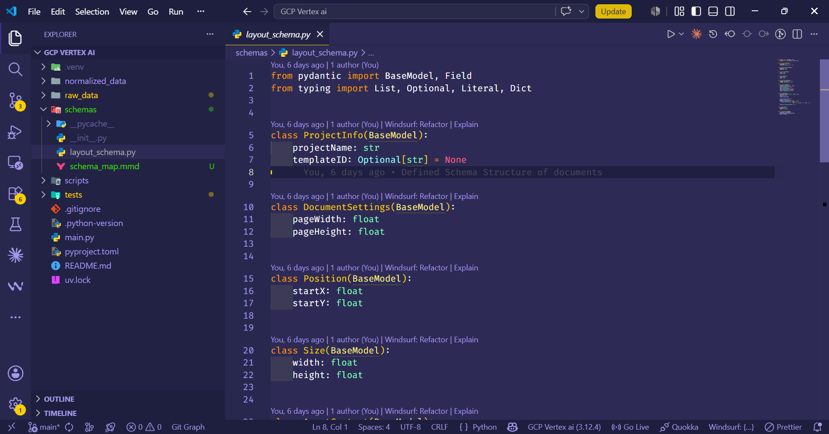
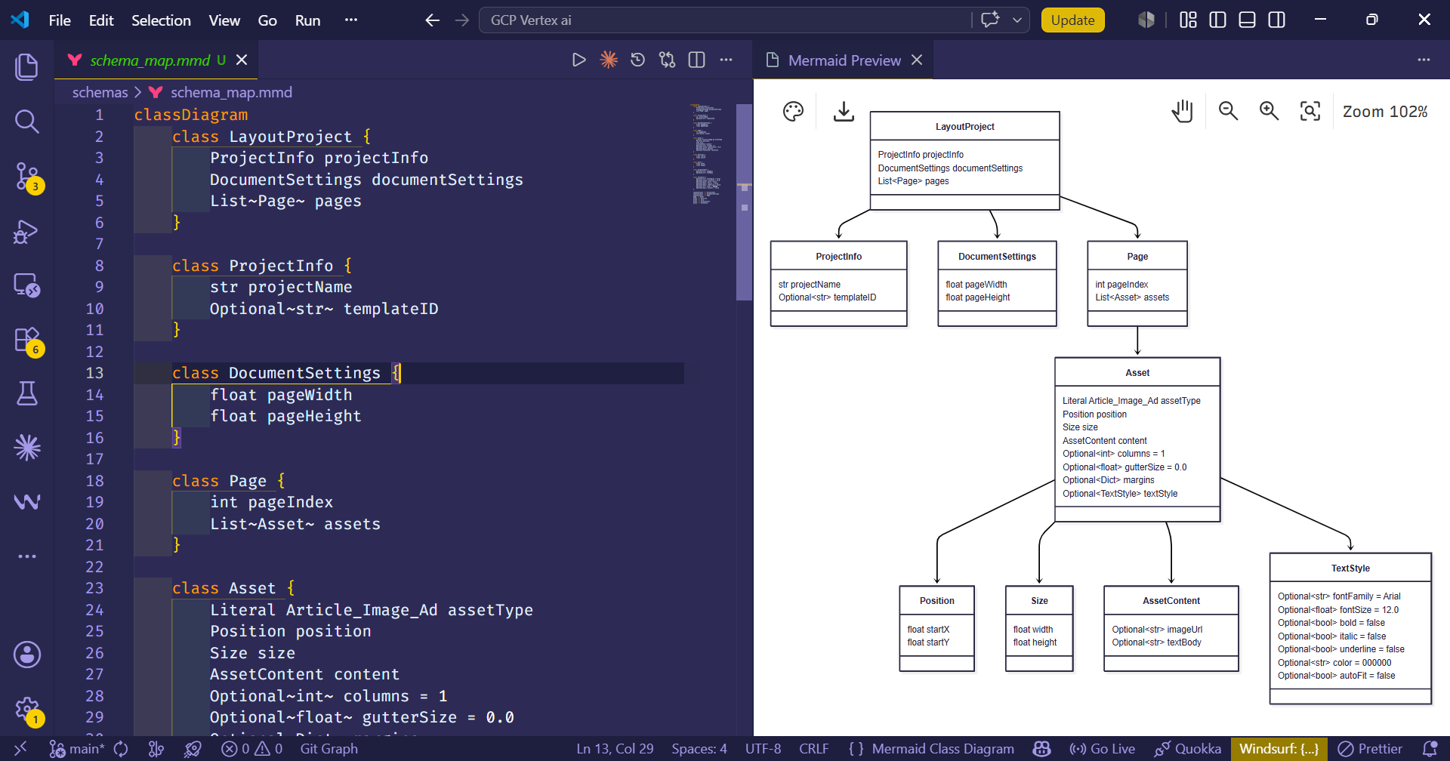
- Define required vs optional fields.
  - Status: Completed.
  - Implementation: The data contract explicitly enforces validation boundaries. Critical spatial geometries (like startX, startY, width, height) are strictly required. Conversely, asset-dependent styling attributes (like templateID, fontFamily, color, and gutterSize) are designated as Optional with built-in default fallbacks to ensure the pipeline doesn't crash on flexible design choices.
- Identify how custom text, linked articles, image settings, and page metadata are represented.
  - Status: Completed.
  - Implementation: Content rules are fully structured inside an AssetContent schema, correctly evaluating imageUrl paths against textBody strings. To guarantee everything was represented flawlessly, we built an automated testing suite (tests/validate_prompt_library.py). We streamed the compiled reference layouts through our Pydantic rules, achieving a perfect compliance score with zero anomalies.

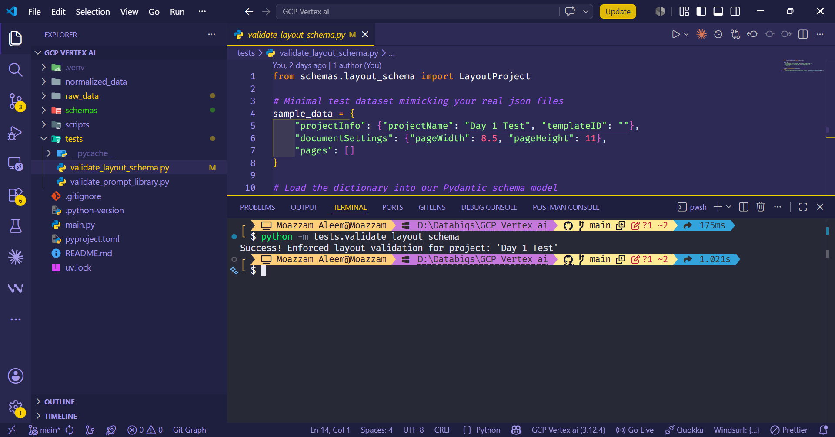
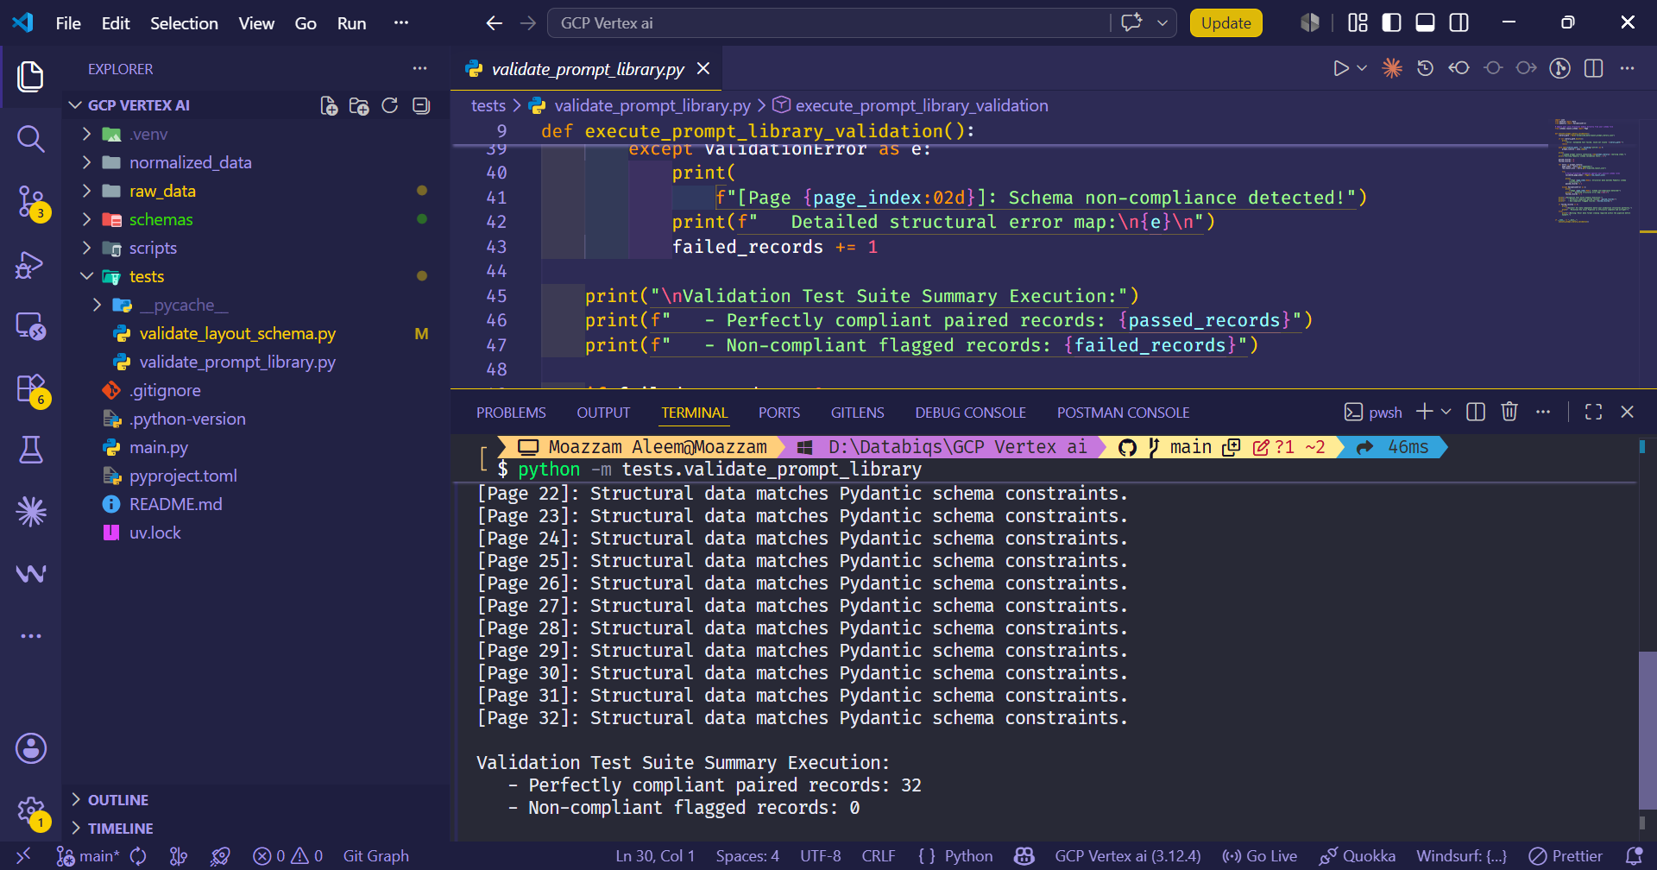
Repository Access & Verification
To provide complete transparency and allow your technical team to review the architectural foundation, all source code, data schemas, and validation test suites for Milestone 1 have been pushed to a dedicated repository.
[Access Repo Here]
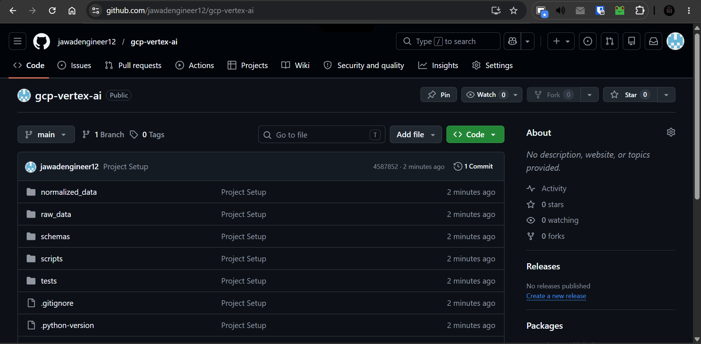

Summary
Milestone 1's local data engineering pipeline is officially 100% complete and airtight. By handling these normalizations and mappings strictly on our local environment first, we have ensured a robust foundation. We are now fully cleared to begin Milestone 2, which entails provisioning the secure Google Cloud sandbox and establishing the Vertex AI integration.

